**WEB PROGRAMING PRACTICUM REPORT**

**MODULE 4**

**SQL**



**CREATED BY :**

**KURNIAWAN BAGASKARA**

**L200214253**

**INFORMATICS STUDY PROGRAM**

**FACULTY OF COMMUNICATION AND INFORMATION SCIENCE**

**MUHAMMADIYAH SURAKARTA UNIVERSITY**

**Percobaan 1 ( Membuat Data Base)**

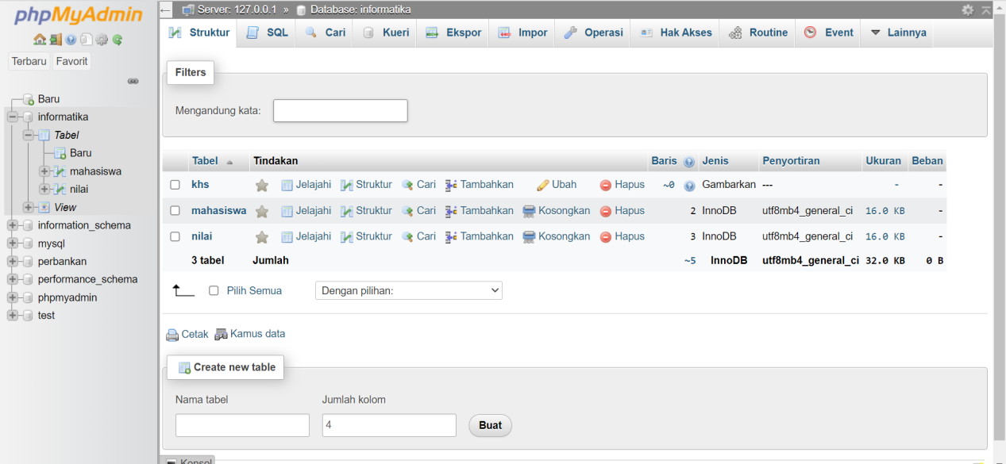

**Percobaan 2 ( Membuat Table )**

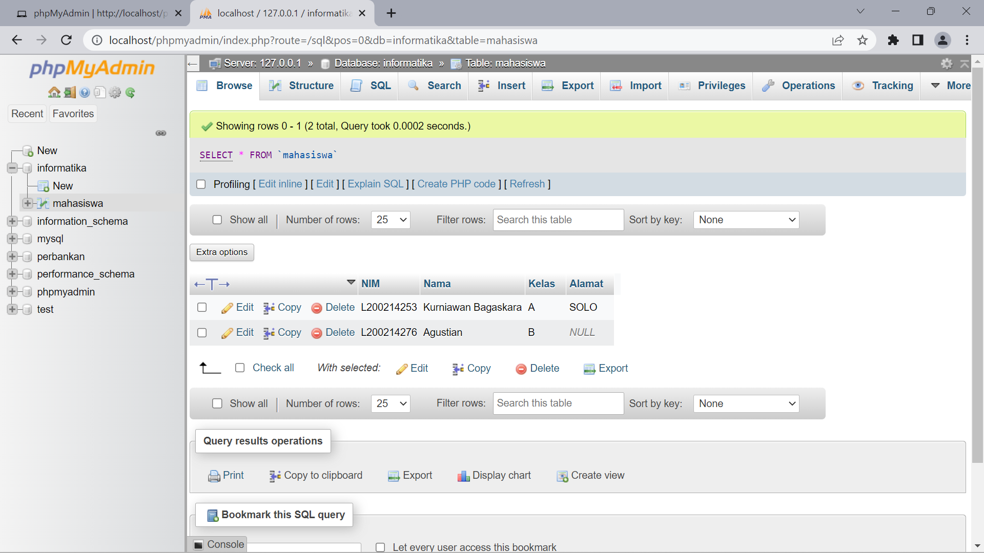

**Percobaan 3 ( Memasukan Data )**



**Percobaan 4 ( Mengubah Data )**

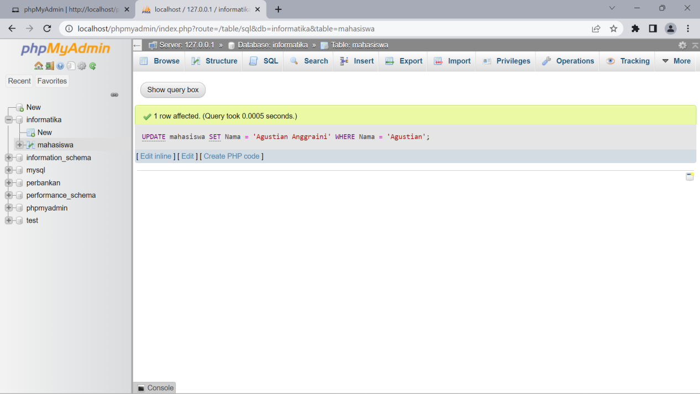

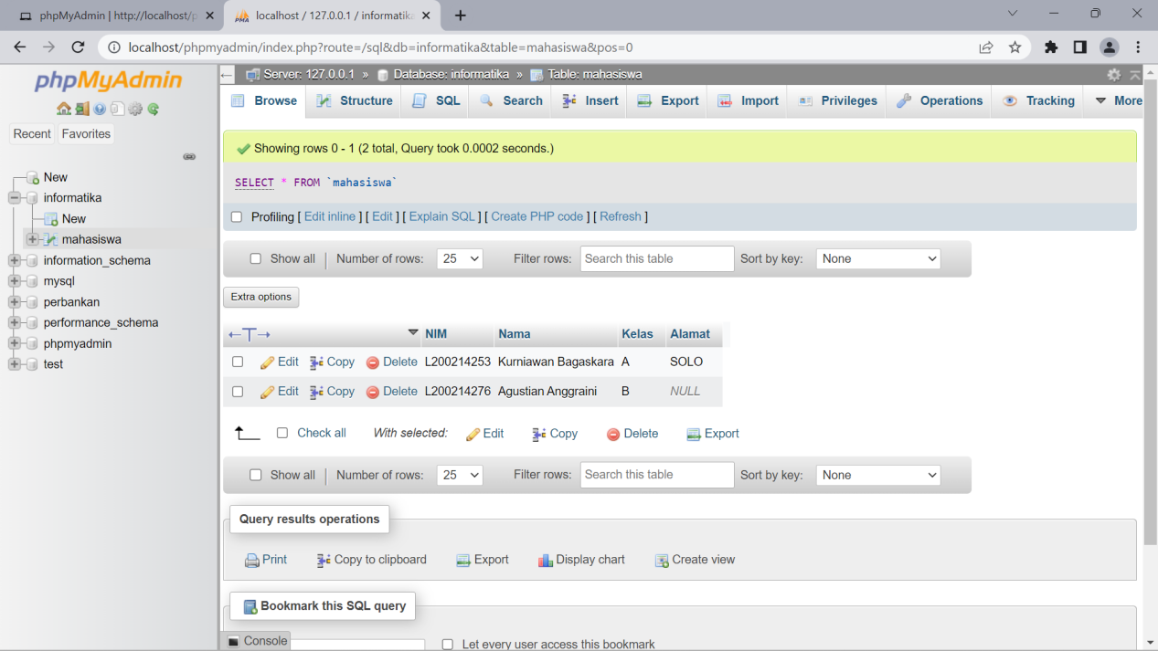

**Percobaan 5 ( Join )**

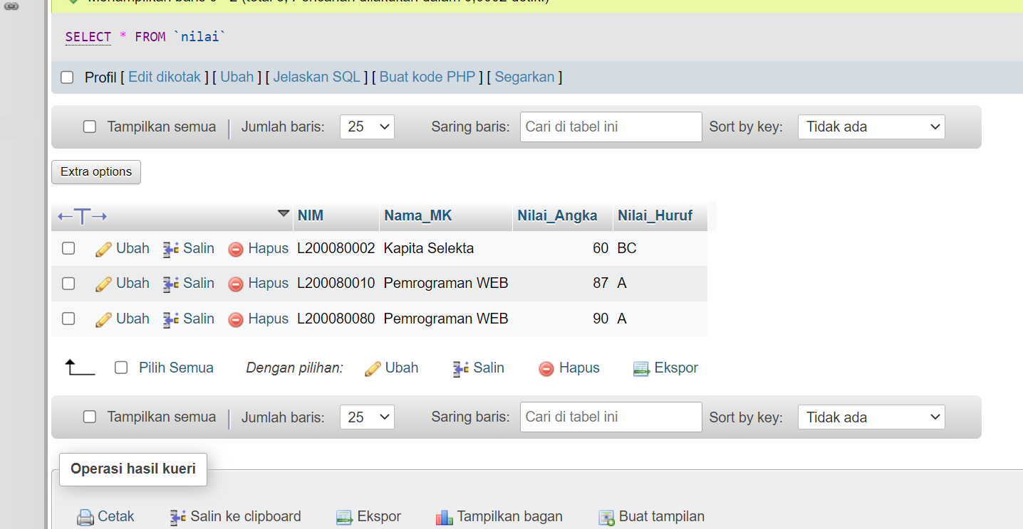

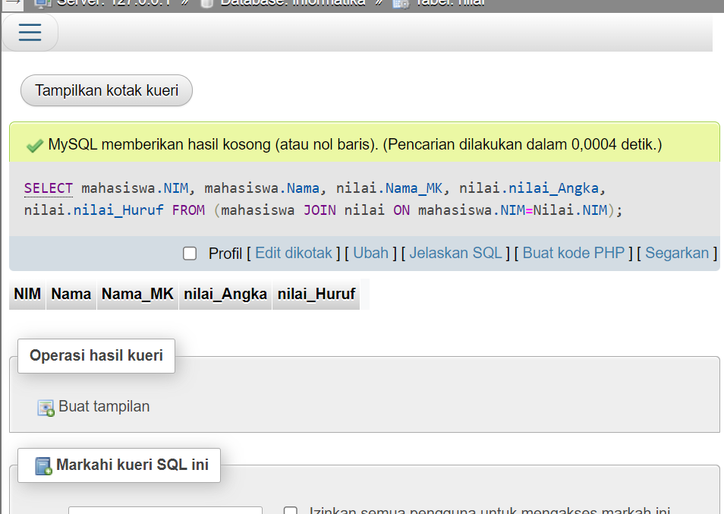

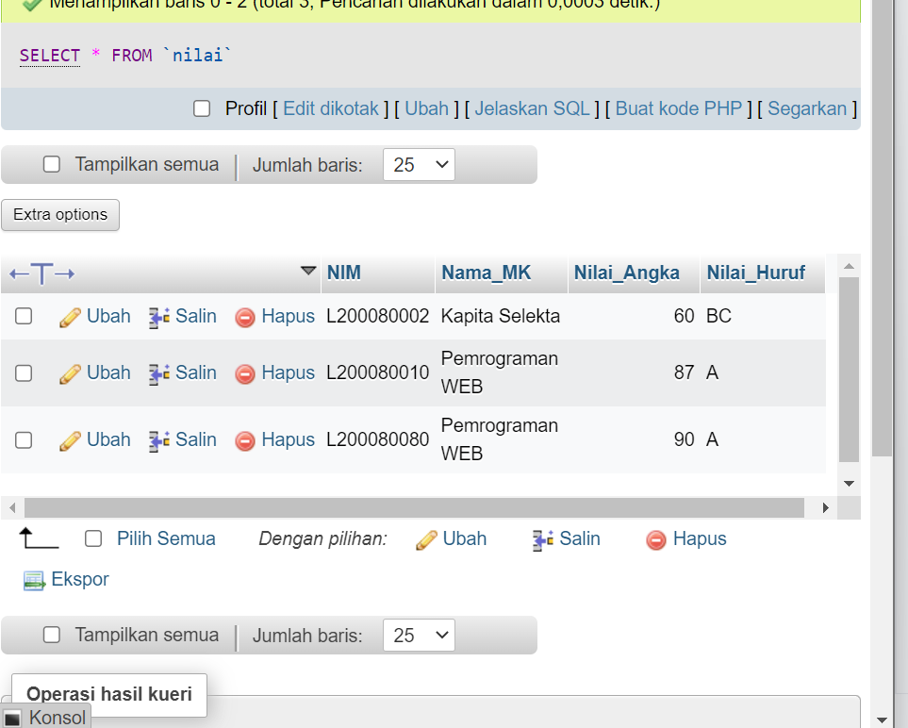

**Percobaan 6 ( Left Join )**

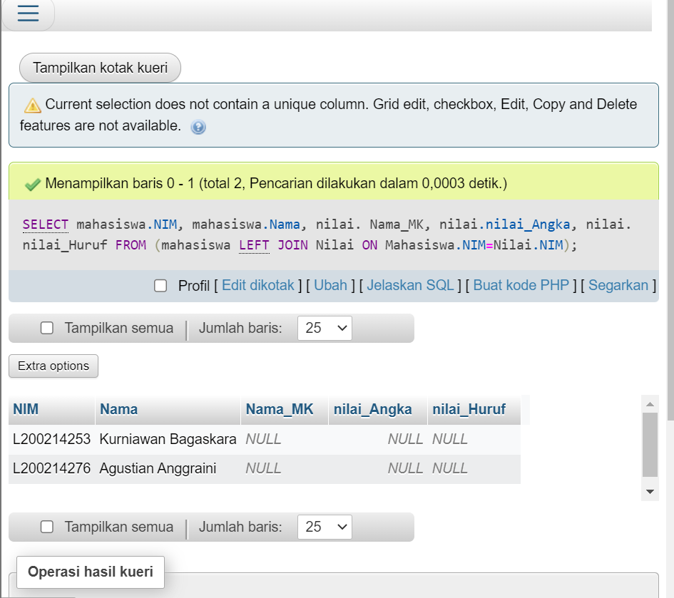

**Percobaan 7 ( Right Join )**

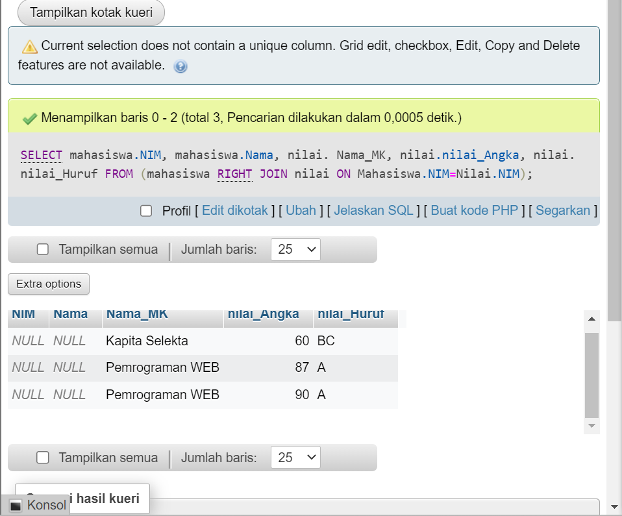

**Percobaan 8 ( Fungsi AVG )**

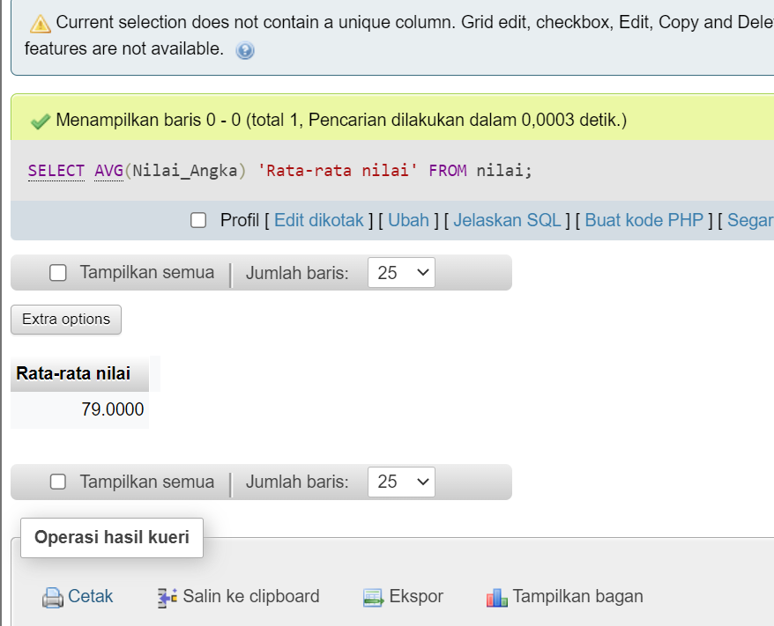

**Percobaan 9 ( Fungsi SUM )**

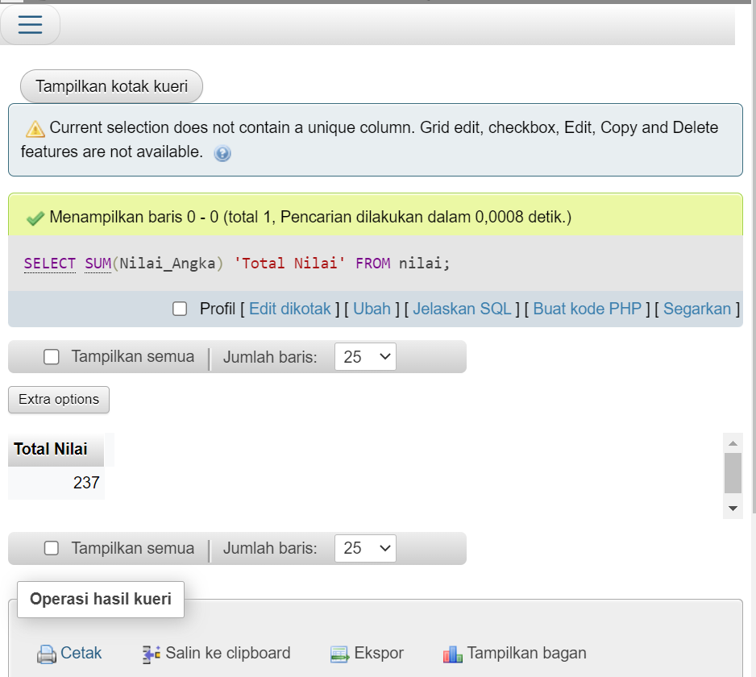

**Percobaan 10 ( View )**

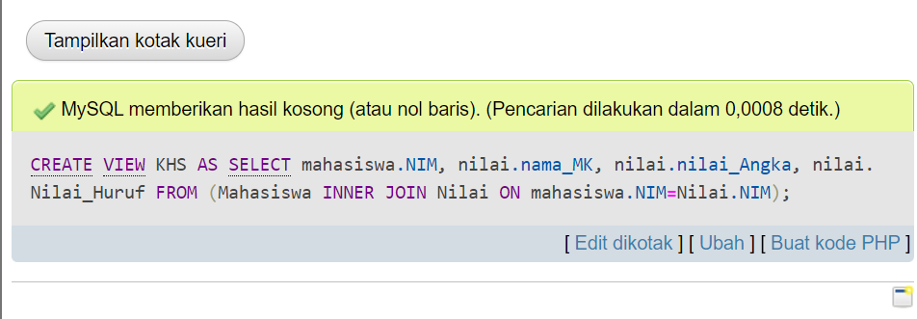

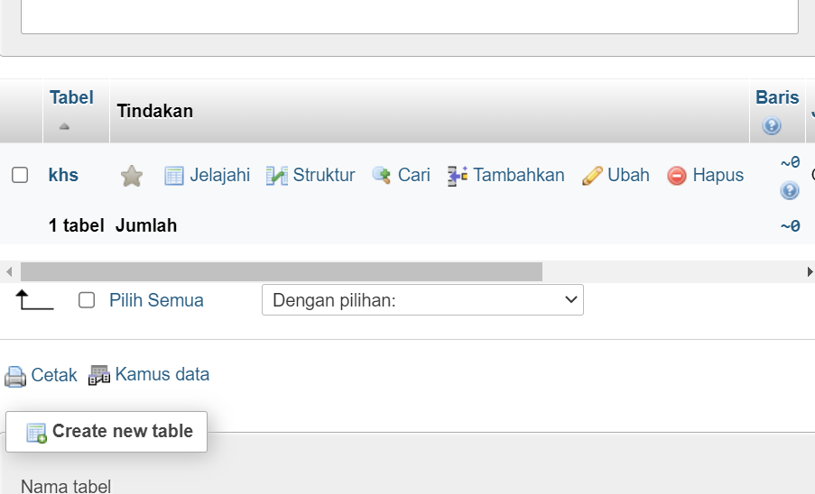

**E. Assignments**

1. What is the function of the following things:

» SELECT

» JOIN

» LEFT JOIN

» RIGHT JOIN

» AVG

» SUM

2. Write SQL Syntax to fill Address data “Sragen”

pada tabel Mahasiswa (percobaan 3) pada NIM L20008080.

**Answer**

* SELECT : SELECT is used to select or display a specific column from a predefined table. In a SELECT statement, we can also perform simple mathematical operations, grouping, and sorting data
* JOIN : JOIN is used to join two or more tables in a database based on the common column between them. By using JOIN, we can retrieve data from two or more related tables and combine them into one resulting data.
* LEFT JOIN: LEFT JOIN is used to retrieve all the data from the table to the left of the JOIN, including the unpaired data in the table to the right of the JOIN.
* RIGHT JOIN: RIGHT JOIN is the opposite of LEFT JOIN. RIGHT JOIN retrieves all data from the table to the right of the JOIN, including unpaired data in the table to the left of the JOIN.
* AVG: AVG is used to calculate the average value of a numeric column in a table. AVG will take the numeric values ​​from the specified column and calculate the average.
* SUM: SUM is used to calculate the sum of a numeric column in a table. SUM will take the numeric values ​​of the specified columns and add them up.

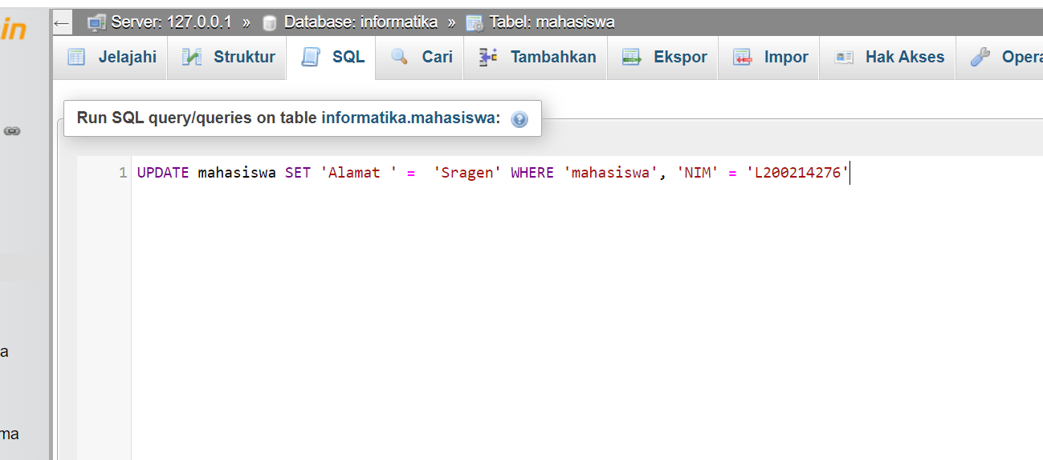

UPDATE mahasiswa SET ‘Alamat ‘ = ‘Sragen’ WHERE ‘mahasiswa’, ‘NIM’ = ‘L20008080’

